Dear Mayor,

On behalf of the Executive Committee, we are pleased to invite you personally to the GPM Annual Summit 2022 “Transforming Together: How Cities Must Lead Democratic, Inclusive and Innovative Global Change”. The GPM Annual Summit will be organised as an in-person event and will take place at the Silesian Museum in Katowice, Poland, on June 24-25. This year, the GPM Annual Summit will be held in connection with the World Urban Forum (WUF) from June 26-30, also hosted by the city of Katowice, which will create synergies and opportunities for mayors attending both events.

The GPM Summit will meet the question of change in an unpredictable world. Recent global developments have created new challenges in our society. Our cities must find solutions for long developing challenges and rapidly emerging crises. We must offer hope, opportunity and dignity to the millions who are migrating into our cities from within our countries and across borders.

The theme of the WUF is “Transforming our cities for a better Urban Future”. The GPM Summit will take on this idea but within the framework of democratic transformation, with a focus on developing and delivering effective and sustainable policy, at a local level, and with particular attention to the opportunities and challenges afforded by migration in its many forms.
The Summit will include mayoral debates on the topics of Welcoming Migrants, Democratic Processes, and Social Infrastructure to advance policy development, exchange and implementation within the framework of the Summit theme. Please refer to the GPM website for more information on the Summit programme.

We sincerely hope to welcome you to Katowice in person. If you are not able to attend the GPM Summit in person, we would appreciate it if you could attend the mayoral debates online. Please let us know if you can accept the invitation by registering (either in person or online) at the following link: https://globalparliamentofmayors.org/annual-summit-2022/ .

We are looking forward to seeing you in Katowice.

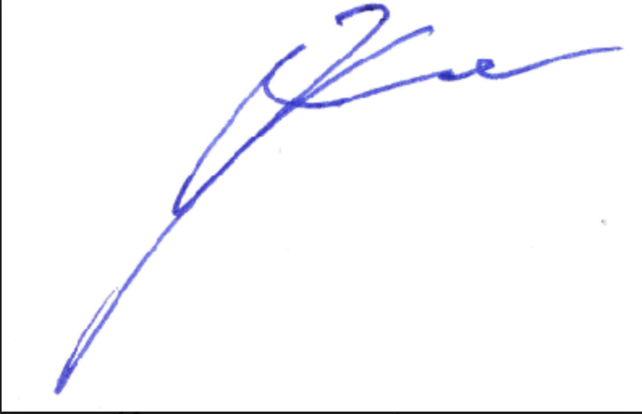
Sincerely,

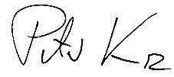

Dr Peter Kurz Marcin Krupa
Chair Executive Committee Member Executive Committee
Mayor of Mannheim, Germany Mayor of Katowice, Poland
Host GPM Annual Summit 2022

